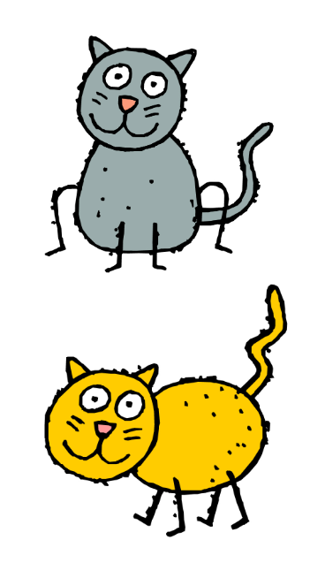The Cat Opera by Gioachino Rossini